Python Practical Assignment

1. Grade Checker
Program
score = int(input("Enter Score: "))

if score >= 90:
print("Grade: A")
elif score >= 80:
print("Grade: B")
elif score >= 70:
print("Grade: C")
elif score >= 60:
print("Grade: D")
else:
print("Grade: F")
Explanation
This program accepts a score from the user and uses if-elif-else statements to determine and display the appropriate grade.

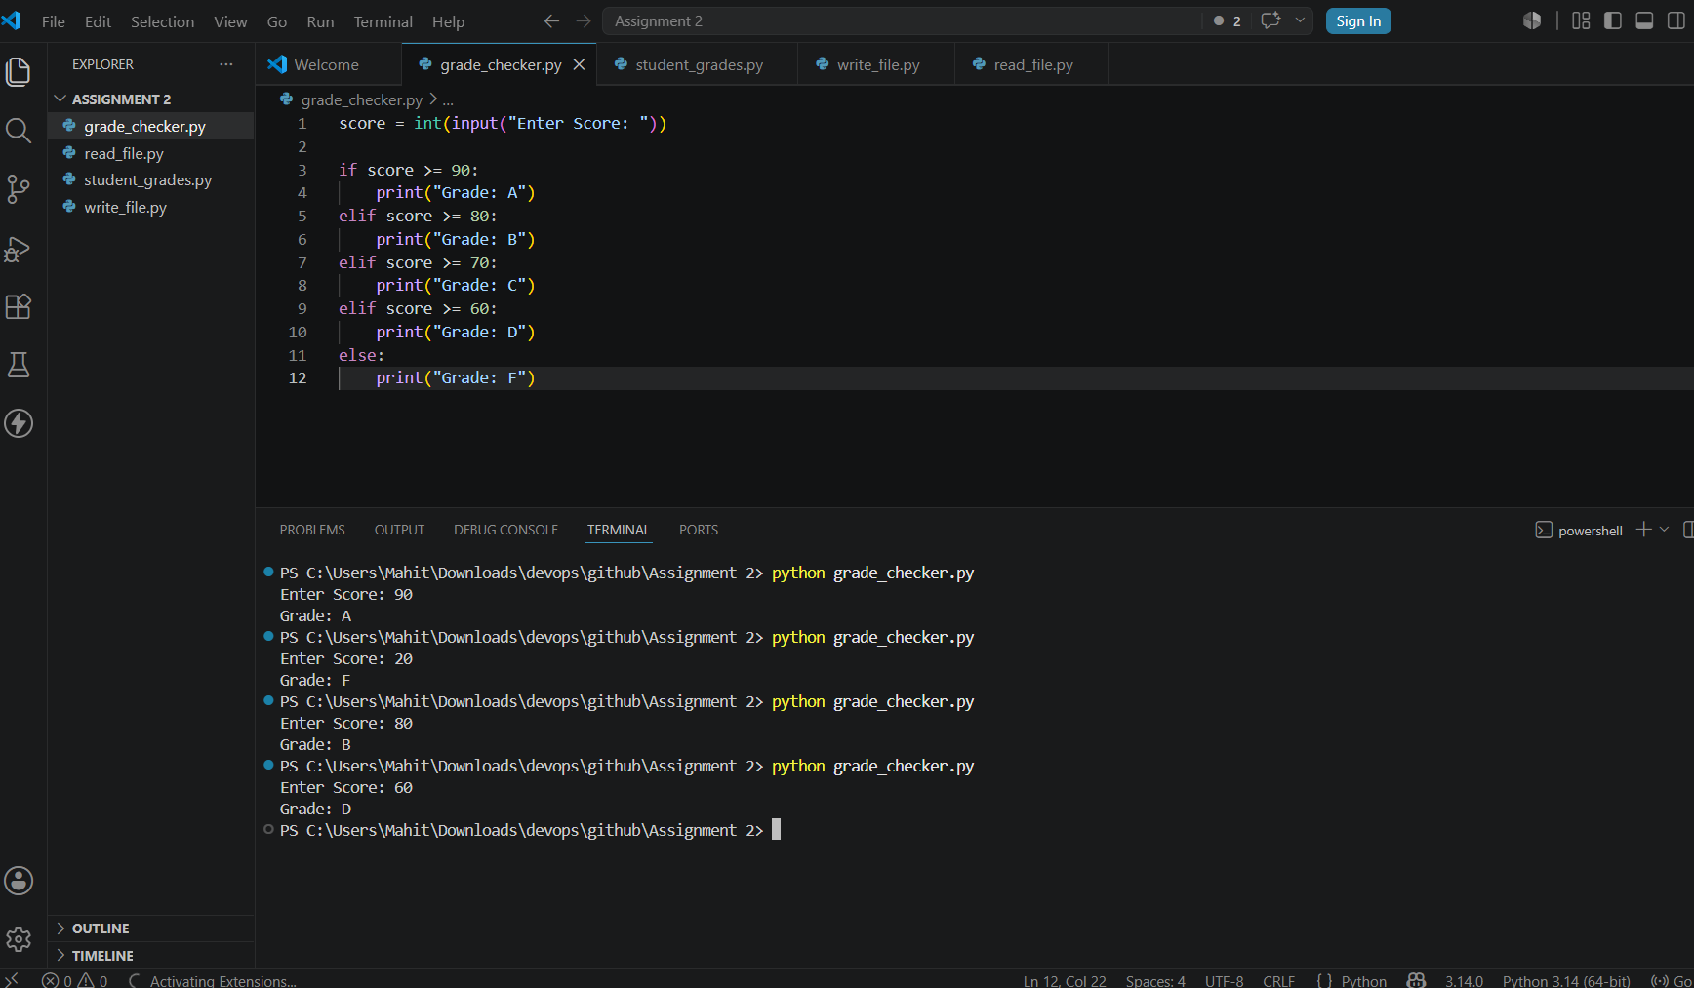

2. Student Grades Dictionary
Program
students = {}

name = input("Enter Student Name: ")
grade = input("Enter Grade: ")
students[name] = grade

update_name = input("Enter Student Name to Update: ")

if update_name in students:
new_grade = input("Enter New Grade: ")
students[update_name] = new_grade
else:
print("Student Not Found")

print("\nStudent Grades")

for name, grade in students.items():
print(name, ":", grade)
Explanation
This program uses a dictionary to store student names and grades. It allows adding a new student, updating an existing student's grade, and displaying all student records.

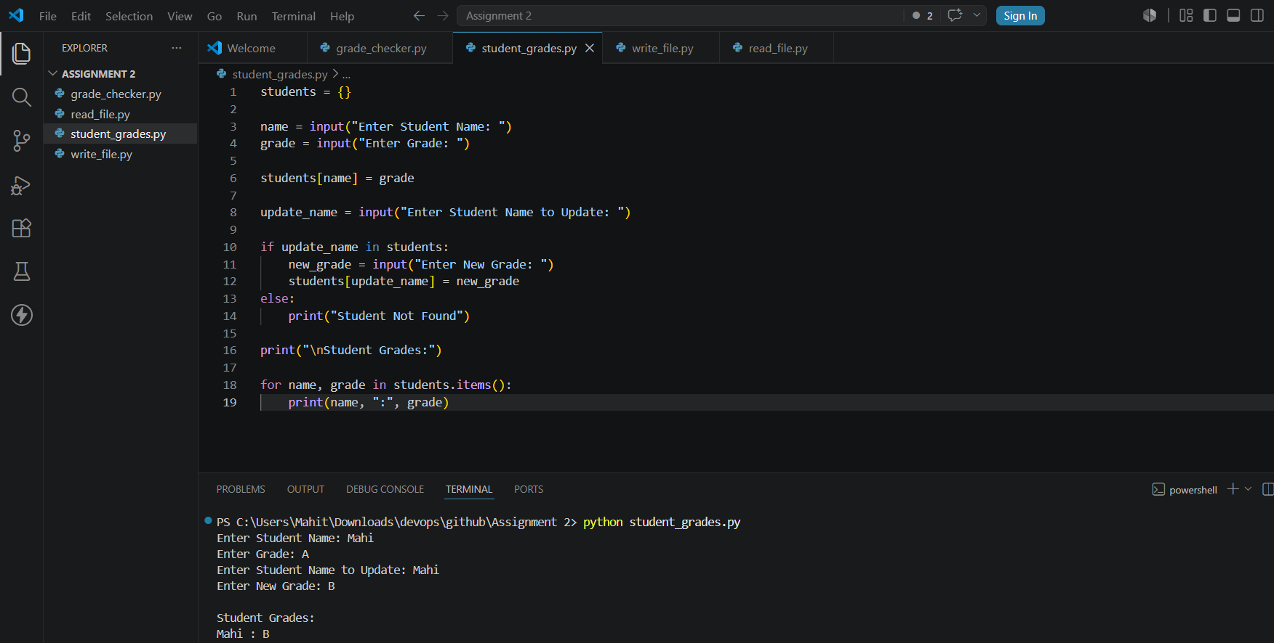

3. Write to a File
Program
file = open("sample.txt", "w")

file.write("Hello World\n")
file.write("This is a Python File Handling Example")

file.close()

print("Content Written Successfully")
Explanation
This program creates a text file and writes content into it using the write() function.
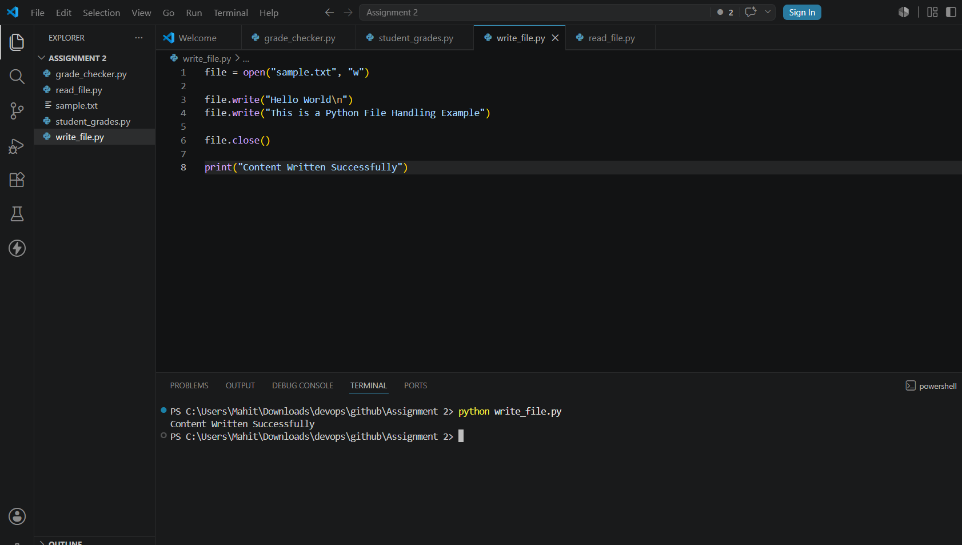

4. Read from a File
Program
file = open("sample.txt", "r")

content = file.read()

print(content)

file.close()
Explanation
This program opens a file in read mode, reads its contents using read(), and displays the contents on the screen.
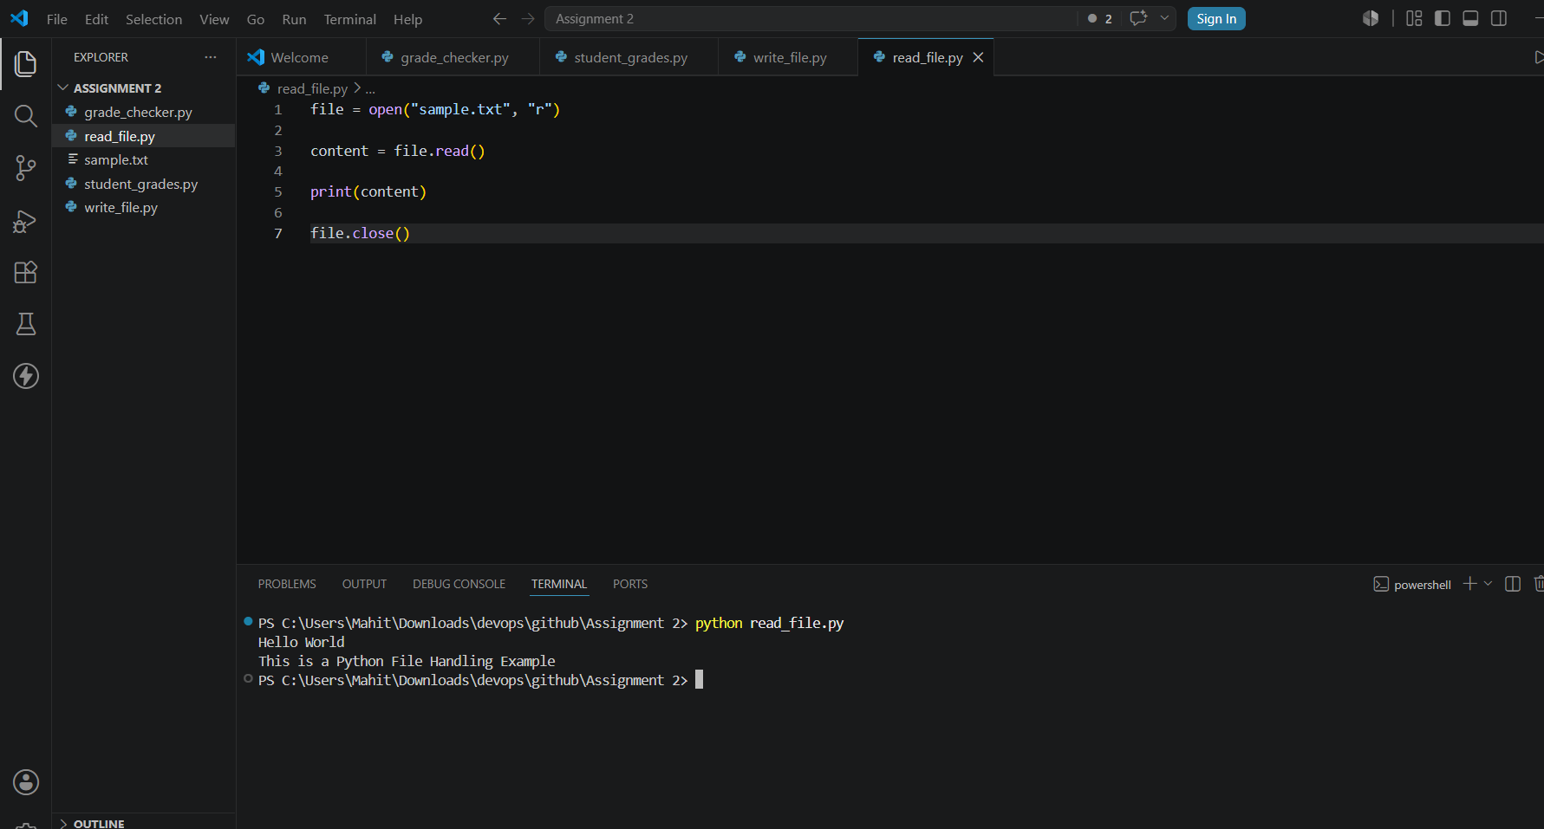

GitHub Repository Link
Paste your GitHub repository link below:
https://github.com/Mahimendha28/linux-assignment.git

